**ANALYSIS REPORT ON EDGE LINE SUPERSTORE SALES**

**INTRODUCTION**

The dataset is for the analysis and reviewing of sales data to identify patterns and trends. The dataset used contains information about Sales Transactions, Customers, Products, and Geographical Locations.

**ABOUT THE DATA/ DATA COLLECTION**

This is a structured and secondarily collected data. The data contains a table in csv files and has 9994 rows and 28 columns. The dataset was given by Ganiyat Olajumoke Ajala.

The analysis to be carried out is to answer the following questions;

1. What is the number of Sales made from each State?
2. Identify the top 5 Products with the highest number of Sales.
3. What are the Sales and Profit made from each Segment?
4. What is the category with the highest Profit?
5. What is the total Sale made from each Category?
6. What is the Quantity sold for each category?

**TOOLS**

The tool used is Microsoft Power BI for analysis and Power Query for data cleaning.

**DATA CLEANING AND TRANSFORMATION**

The following are the different cleaning procedures;

* The order and ship date data type were changed to short date data time.
* The postal code column data type was changed to text data type.

**EXPLORATORY DATA ANALYSIS AND INSIGHT**

For the analysis to be understood and questions answered, charts were created using the power bi visualization tools for proper analyzation and insights. Below are the questions, its analysis and insights;

1. **What is the number of sales made from each state?**

In order to the sales generated from each state, the “State” and “Sales” were filtered. Recording a sales value of $457,687.63, California topped the charts as the state with the highest number of sales. Followed by New York with sales value of $310,876.27; and the state whose sales value was least is Virginia, generating only $919.19 sales. The total sum of sales generated from all states accumulated to $2.30m.

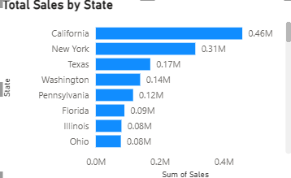

A stacked bar chart was used to show the total sales for each state.

1. **Identify the top 5 Products with the highest number of Sales.**

To find out the top 5 products generating the most sales, the “product Name” and “Sales” were filtered. With sales value of $61,599.82, Canon ImageCLASS2200 Advanced Copier was shown to be the product with the highest number of sales; seconded by the product “Fellowes PB500 Electric Punch Plastic Comb Binding Machine with Manual Bind” with sales value of $27,453.38. the third product with high number of sales is “Cisco Telepresence System EX90 Video conferencing Unit” with sales value of $22,638.48. followed by “HON 5400 Series Task chairs For big and Tall” as the fourth product with high number of sales, totaling a sales value of $21,870.58. the fifth product with high number of sales is “GBC DocuBind TL300 Electric Binding System” with sales value of $19.823.48.

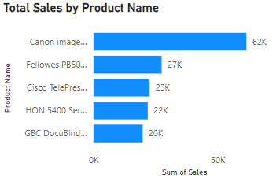

A stacked bar chart was used to show the top 5 products by sales.

1. **What are the Sales and Profit made from each Segment?**

To analyze the sales and profit made from each segment, the “Sales”, “Profit” and “Segment” were filtered. The Consumer segment recorded a sales value of $1,161,401.34 and profit of $134,119.21; making it the segment with the highest number of sales and profit. The Corporate segment generated a value of $706,146.37 in sales and $91,979.13 in profit. The last segment and also the segment with the least number of sales and profit is the Home Office segment; recording a total of $429,653.15 in sales and $60,298.68 in profits.

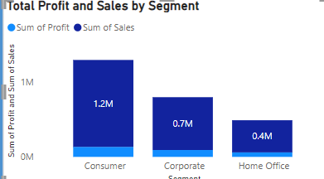

A stacked column was used to represent the sales and profit for each segment.

1. **What is the category with the highest Profit?**

In order to know the category with the highest profit, “Category” and “Profit” were filtered. With total profit of $145,454.95, the “Technology category” was shown to have the highest number profit. The next category with high profit value is the “Office Supplies category” with profit margin of $122,490.80. the least category with low profit is the “Furniture category” with total profit of $18,451.27.

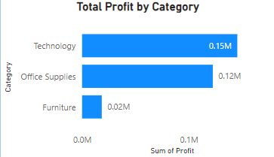

A stacked bar chart was used to represent the category with the highest profit.

1. **What is the total Sale made from each Category?**

In order to know the total sale made from each category, “Category” and “Sale” were filtered. With total sale of $836,154.03, the “Technology category” was shown to have the highest number sales; accumulating 36.4% of total sales. The next category with high profit value is the “Furniture category” with sales value of $741,999.80; making 32.3% of total sales. the least category with low sales is the “Office Supplies category” with total sales of $719,047.03; making up to 31.3% of total sales.

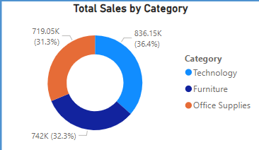

A donut chart was used to represent the total sales generated for each category.

1. **What is the Quantity sold for each category?**

To analyze the quantity sold for each category, the “Quantity”, and “Category” were filtered. The “Office Supplies category” sold a quantity of 22906; making it the category with the highest number quantity sold. The furniture category sold a quantity of 8028. The last category and also the category with the least sold quantity is the “Technology category; recording a total of 6939 quantity of items sold.

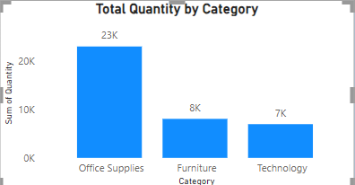

A clustered column was used to show the quantity sold for each category.

**RECOMMENDATION**

After carefully analyzing the data set, it clearly shows that the Technology category is the most profitable and generate lots of sales in major states. the furniture category has the least profit margin which inquire loss for the organization. The office supplies category made moderate profit, although it recorded low sales. Lastly, some states showed very little profits and sales on all categories. My recommendation is to find out the reason why most of the states are having poor sales and change marketing strategy or stop sales in these states. Also the resources channeled towards furniture category should be limited and channeled towards the technology category as it generates less profit.